**Web-a-thon**

Web-a-thon is a 12-hour hackathon which is being conducted over night. In these 12 hours the participants should make an effective and attractive full stack web application. This is a team event with a team size of maximum 4 members.

In this hackathon the teams would be given a problem statement on the spot. Thus, the participants have to build the web application according to the given problem statement. It’s the participants’ choice to use whatever technology they wish.

There will be a total of 3 phases of evaluation in which an external judge will be looking after the work that is being done. The judgement will be given by the external judge. The winners will be declared based on the web application that meet the requirements.

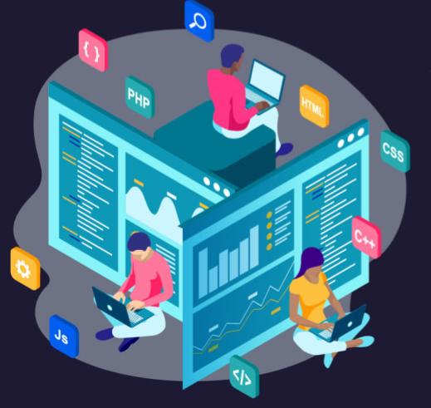

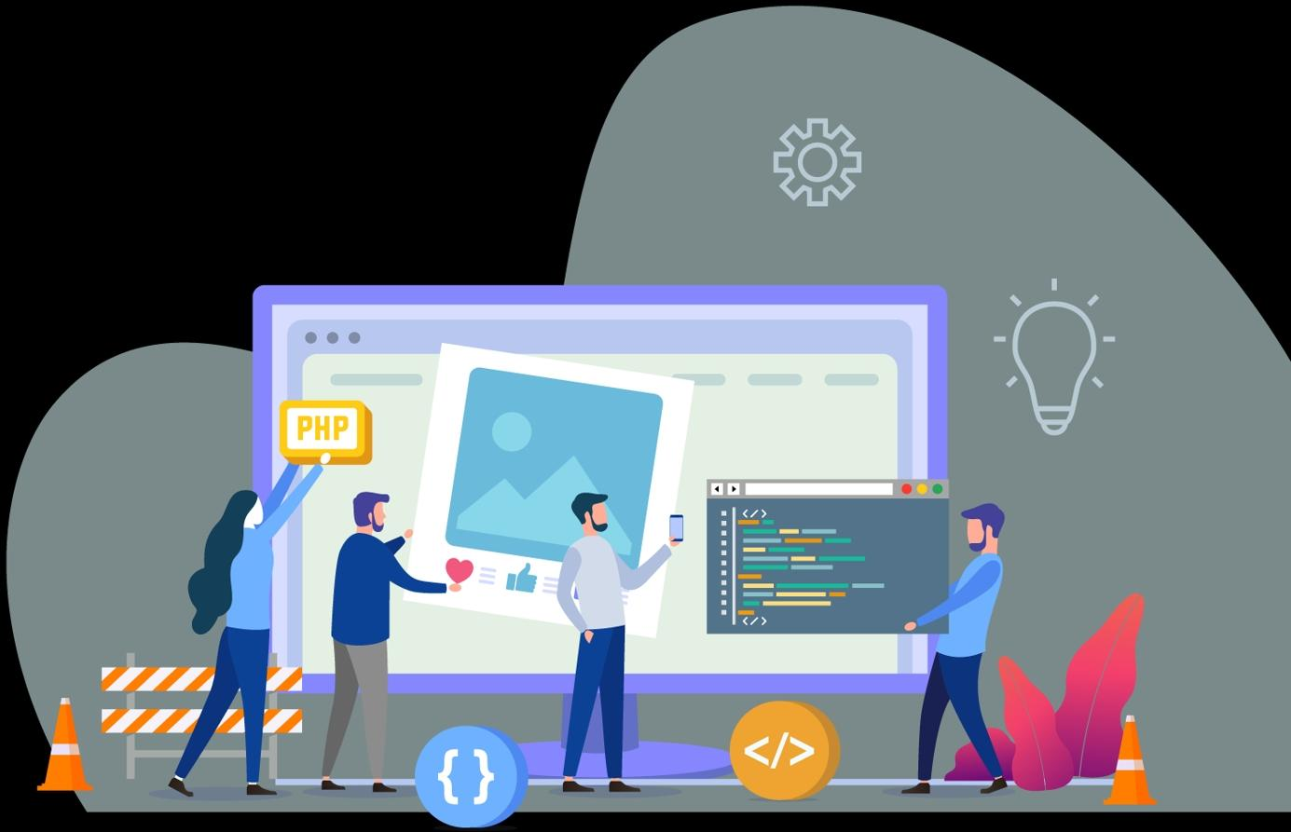

**Codigo**

* Max of 2 members per team.
* First prize 15000/-
* Second prize 10000/-

There are 3 Rounds:

1.pattern Printing

2.Unlock Me

3.Lock Out

This event allows participants to bring out their team spirit, ideas to solve different kind of problems. The event tests the participants ability to think in a unique and fast manner to reach goals.

* In the first Round (pattern printing). In this there will be 4-5 Questions on printing patterns. patterns with alphabets, numbers, different symbols will be given. On solving every question participant awarded with marks. Based on the marks only they were promoted to next round.

Best 20 teams selected for the next round.

* In the second Round (Unlock Me). We will provide a question in one system answer will be the password for the next system. Likewise, you have to open systems. Based on number of systems opened and time final 4 teams are selected.
* In the third Round (Lock Out). We will provide 100 questions to all teams. If any one of the team did a question that question will be locked for other teams. Team with high Score will be the winners.

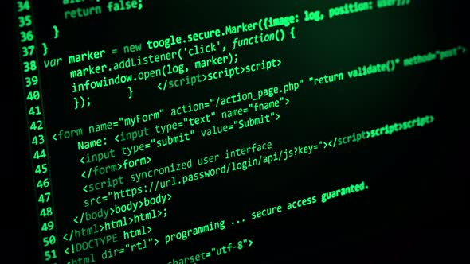

**League Of Legends**

This Esports events comprise many games, both popular and under the radar, in

numerous genres. We divided this event into 3 Sub-events,

1 - Mobile based (Main Stream events, which need a cash prize)

2 - PlayStation (PC) (Revenue generating events, no need to have prize pool)

3 - Virtual Reality (Revenue generating events, no need to have prize pool)

Esports (also known as electronic sports, eSports, e-sports, or competitive/professional gaming) are a form of competition using video games. Most commonly, esports take the form of organized, multiplayer video game competitions. In these there are two games namely battle grounds and free fire.  these games are live streamed in our college YouTube channel and there will be commentators for the engagement of audience with the event. these games are conducted in rounds. top winners have again will be played in final round. there will be group of four in each team. There will be waiting time in the lobby for each game for approx. 15 min. so in this time we like to do some presentations about the current evolution of blockchain gaming. In these Two games, battle grounds game will be played by 100 members (25 teams) at a time and free fire can be played 48 members (12 teams) at a time.

And coming to other two parts, they are like pay & play type. Where we provide a place and devices to play most trending PC games according to the time constraints we have. These include PC and VR boxes.

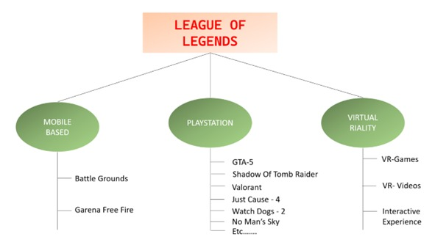

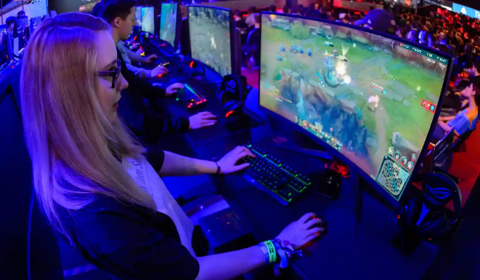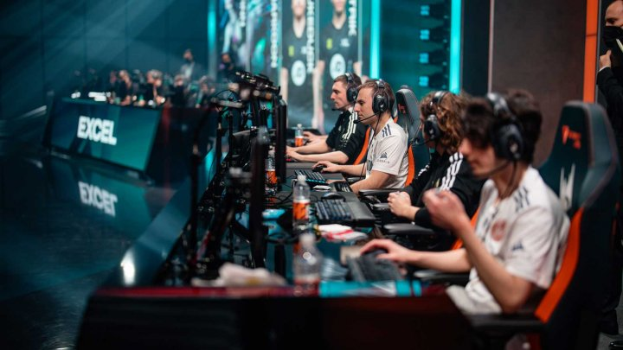

**CODE MANIA**

**Round 1: LOGIC MANIA**

Three Problem Statements will be given to participants, these problem statements only contain Inputs and outputs rather than the description of the problem. Participants must write a code that satisfies all the test cases for the given input and output.

**Round 2: CODE AUCTION**

Code Auction is a team-based event, where each team gets credits of 500 CSI Coins. These coins can be used to buy Problem Statements during the auction of a problem statement. Each problem statement has some base points based on the difficulty of the statement. After a team buys a problem statement, if the team solves the code, then the team’s points will be increased by the base price of the statement. A team cannot buy another code if they didn’t solve at least 40% of the code. After all the codes are sold, the team with the highest points is declared the winner.

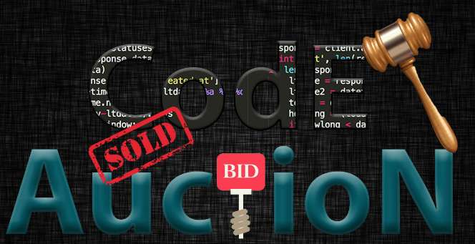

**Model UN**



**Description:**

 Model United Nations is a student driven UN Conference which provides students to enrich their abilities like critical thinking, research, documentation, speaking, understanding, analysing and what not. Model UN was started by Oxford University in the year of 1921, and was still popular worldwide among the students who would love to improve their communication, negotiation skills. Model UN is a collection of activities conducted all across the nation and the world with the objectives of advancing knowledge of UN, teaching participants about global concerns and promoting peace through collaboration and diplomacy.

Some of the topics discussed during Model UN are:

* Specpol (Special Political and Decolonization)
* UNHRC (United Nations Human Rights Council)
* UNSC (United Nations Security Council)
* Some crises related problem statements
* Military Cooperatives
* Women and Child Development
* FGM (Female Genital Mutilation)

Students must collaborate among themselves and speak regarding the topics and must maintain a healthy debate among their other countries delegates to promote peace and harmony.

This is a platform where different ideological students come together form teams and discuss the problems and the current issues which are being faced throughout the world.

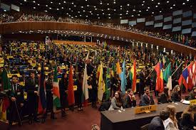

**Outcomes:**

This helps the participant to think out of the context in which he can inculcate much intended needy skills like leadership skills, communication skills, problem solving skills, He/she will be able to communicate in a way that how top bureaucrats and diplomats does, they will be aware and knowing the context that what is actually happening in the globe, The participants will be able to understand the geopolitics that is currently hot-streaming in the world, they will learn that how top diplomats behave and the way the live their life cause the participants must have to act upon during the throughout the Model UN

